**Registration Quick Guide**

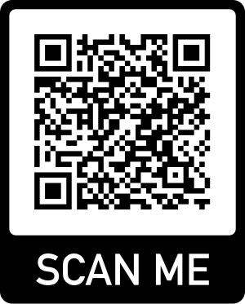

Step 1: Scan this code to begin the pre-registration form

Step 2: Open your email

Step 3: Wait for an email to confirm your pre-registration

Step 4: In your email you will confirm your account - keep your email open

Step 5: Download PowerSchools App- **District CODE: PSQD** or click this link to create your account: <https://bcsd.powerschool.com/public/home.html>

* Create a Powerschools Account
* Enter your recently created username and password to log in

Step 6: Once logged in to the PowerSchools App, click FORMS on the left toolbar.

Step 7: Begin completing the forms

Step 8: Submit once completed

*****You do not need to complete all at once*****